Adarsh Ramgobin

ST10316986

*Table of contents*

1. Essay 300 words
2. Graphics
3. Homepage
4. About page
5. Gallery
6. Service of products
7. Contact
8. List of reference list

*Essay*

Stardust Donations is a non-governmental organization that aims to improve the lives of individuals and communities in need by providing healthcare, clean water, education, and food distribution. The organization operates on the belief that every individual has the right to a healthy and fulfilling life, and that access to necessities such as healthcare, clean water, education, and food should not be a luxury, but a fundamental human right.

Stardust Donations is committed to ensuring that its efforts are sustainable and impactful, and it does this by working closely with local communities and partnering with other organizations to maximize its reach and effectiveness. The organization recognizes that the problems it seeks to address are complex and multifaceted, and as such, it employs a holistic approach to its interventions.

In the area of healthcare, Stardust Donations provides medical supplies, equipment, and expertise to underserved communities. The organization also partners with local healthcare providers to improve access to healthcare services, particularly for vulnerable groups such as women and children. In the realm of clean water, the organization constructs and maintains water wells and provides education on proper hygiene practices to prevent the spread of waterborne diseases.

Stardust Donations recognizes that education is critical to breaking the cycle of poverty, and as such, it provides educational resources and opportunities to individuals and communities in need. The organization constructs and renovates schools, provides school supplies, and offers scholarships to deserving students.

In addition to its healthcare, clean water, and education initiatives, Stardust Donations also provides food distribution to communities facing food insecurity. The organization works with local farmers and markets to provide nutritious food to individuals and families in need.

Overall, Stardust Donations is a non-governmental organization committed to making a positive impact on the lives of individuals and communities in need. By providing healthcare, clean water, education, and food distribution, the organization seeks to address the complex and interrelated issues of poverty and inequality. With a focus on sustainability and impact, Stardust Donations is working to build a better future for all.

Graphics

Homepage

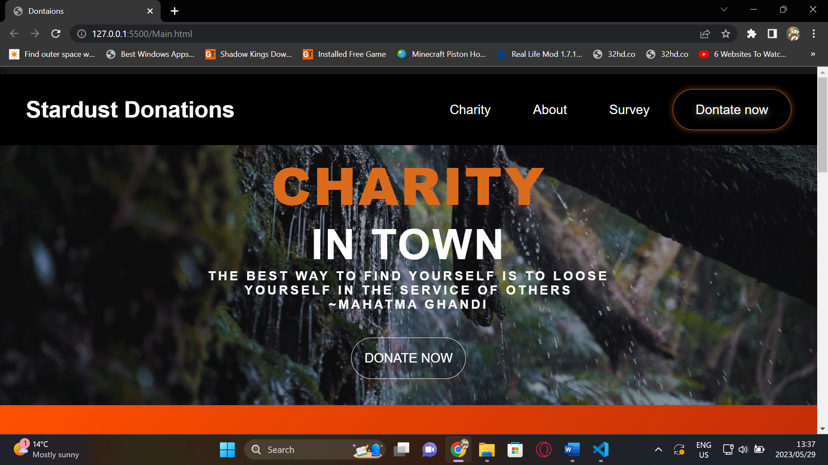

In today's society, when inequalities and sufferings endure, the need for groups that assist people in need is more important than ever. Stardust Donations, a caring company dedicated to making a good difference in society, has arisen as a ray of hope. We will investigate the goal, fundamental principles, and user-friendly elements of Stardust Donations' home page, which collectively symbolize the organization's dedication to impacting lives.

Engaging images: A well-designed home page is incomplete without appealing images, and Stardust Donations recognizes the importance of photography. The page includes touching images of people who have benefited from the organization's programs. These images elicit empathy and compassion, expressing the beneficial influence Stardust Donations has on the lives of individuals they assist.

Clear and Intuitive Navigation: Navigating a website should be a fluid and intuitive experience, and the main page of Stardust Donations succeeds in this regard. A well-organized navigation connects users to various aspects of the website, such as contribution possibilities, success stories, volunteer activities, and the history of the organization.

The user-friendly layout makes it easy for visitors to get the information they need, promoting a pleasurable browsing experience.

About page

The Stardust Donations About page provides a glimpse into the heart and spirit of this wonderful organization. Stardust Donations has become a catalyst for change, inspiring individuals and promoting a brighter future via a deep dedication to having a good effect. This article digs into the substance of the Stardust Donations About page, outlining the organization's purpose, principles, successes, and unshakable devotion.

Purpose and goal: Stardust Donations' About page summarizes the organization's purpose and goal. It communicates Stardust Donations' objective of providing hope, assistance, and resources to communities in need. Stardust Donations sees a society in which everyone has equal access to opportunities, compassion and generosity improve lives, and collective action promotes long-term change. Visitors may learn more about Stardust Donations' mission by visiting the About page.

beliefs and Commitment: The essential beliefs and principles that inspire Stardust Donations are reflected on the About page. The organization's foundation is built on integrity, compassion, inclusion, and openness. It emphasizes the organization's dedication to ethical procedures, appropriate resource stewardship, and genuine concern for people it serves. Visitors to the About page have a better grasp of the ideals that govern Stardust Donations' activities.

Gallery

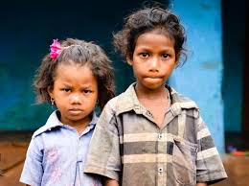

Donation

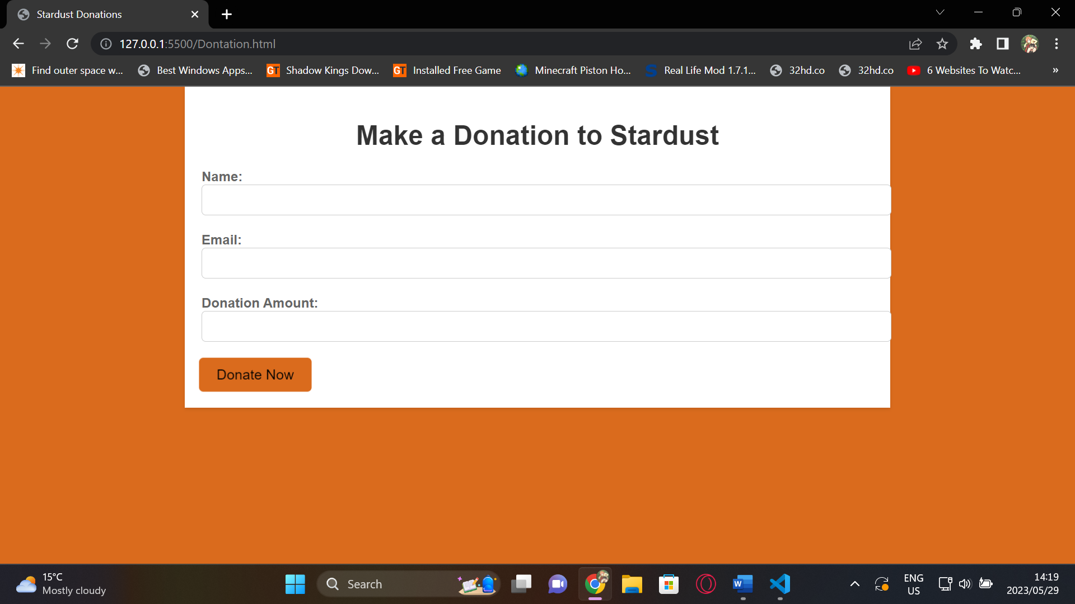

Creating a Connection: The donation page of Stardust Donations serves as a bridge between the organization and potential donors, establishing an emotional connection. Through carefully crafted storytelling and compelling visuals, the page showcases the real-life struggles faced by individuals and communities, compelling visitors to take action and make a difference. By evoking empathy and compassion, the donation page inspires visitors to contribute to the cause. User-Friendly Interface: Stardust Donations understands the importance of a seamless user experience. The donation page features a clean and intuitive interface that simplifies the donation process. Clear calls-to-action guide visitors through the steps, ensuring a hassle-free and efficient donation experience. The page provides options for various payment methods, allowing donors to choose the most convenient option, ultimately enhancing accessibility and inclusivity.

Reference

Images are from google